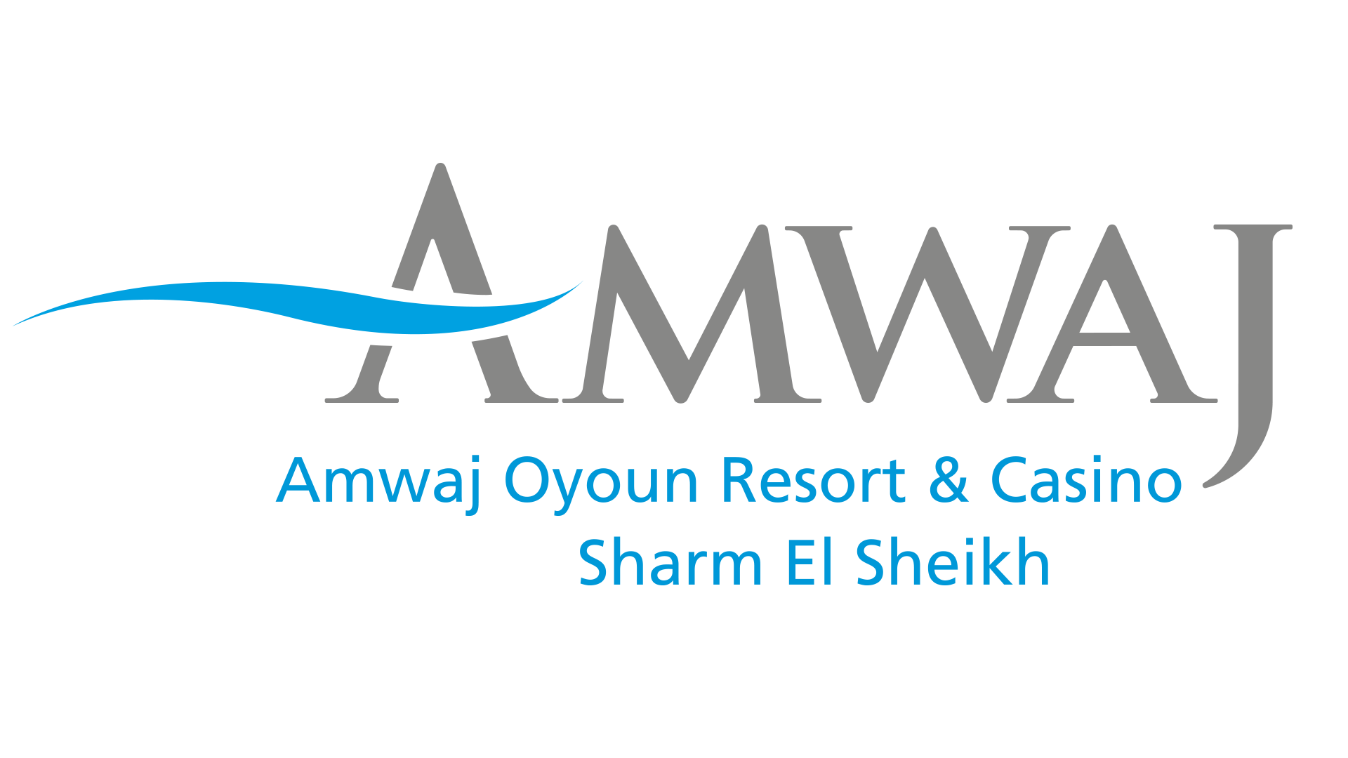

Hygiene Safety Toolkit Post COVID-19

Over the coming days and weeks we will be preparing to reopen some of our Hotels. Our future guests will be expecting to see visible signs that we have taken all reasonable steps to keep them safe whilst they are in one of our hotels.

Hygiene, safety and security are now of paramount importance. It will be key to our success that we show our guests that their welfare has been taken care of.

The following toolkit is designed to help our hotels and resorts understand, plan and mitigate the impact of the COVID-19 pandemic. The toolkit contains clear information and recommendations on adjusting operation procedures . We highlight new ideas of how our resorts can react to the changes. The toolkit is just a base. It will see many evolution in the coming weeks based on practices.

We will be working with International Hygiene & Safety audit experts in the field of hotel risk
management to implement the “Prevention of Spread of Infection” (POSI) management system. The toolkit’s technical references are the WHO, CDC and the Egyptian Ministry of Health (MoH).

- General Disinfection for Hotels
- Human Resources and Staff Training
- Reception and Concierge
- Hotel Rooms
- Dining
- Hotel Leisure Facilities
- Conference Rooms, Banquettes and Exhibitions
- Engineering

- Shops/Bazars/Clinics/Diving Centers
- Suppliers
- Hygiene
- General Manager’s Role
- Crisis Team
- In Case of an Infected Person in the Hotel
- Documents and Records
- Required Equipment
- Application of the Protocol

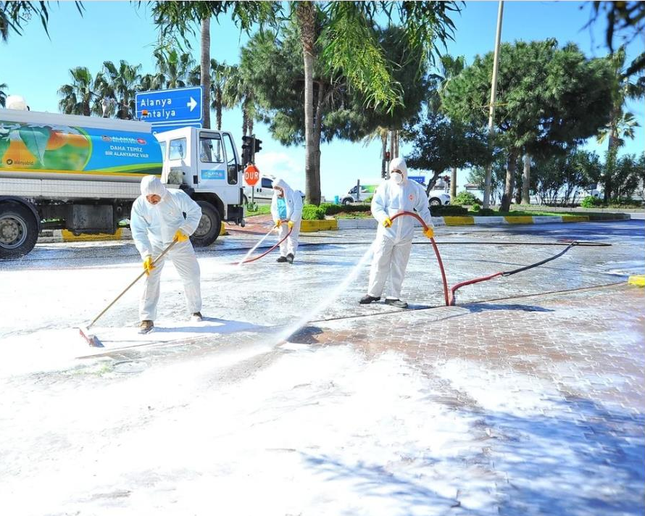

- Under the COVID-19 outbreak and after last guest departure, general disinfection procedures were done by Amwaj Oyoun Resort & Casino with special consideration given to the application of cleaning and sanitation measures in all hotels areas.
- We disinfect frequently the building entrances, public areas, rooms, back of the house areas, vehicles and special attention is given to high touch areas, using 1000 to 4000 ppm sodium hypochlorite, left for 15-30 minutes.

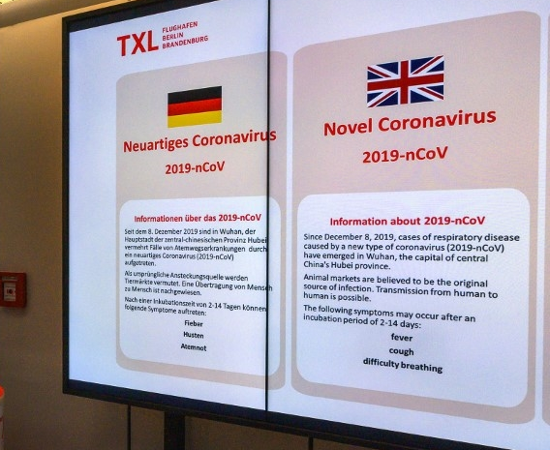

Conditions for Staff:
- Commitment to employ a maximum of 50% of the employment.

- For the resorts in Red Sea & Sinai a (Rapid Test) for

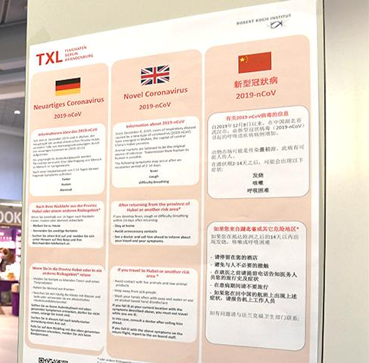
workers before resuming their duties.

- The rapid testing of workers at the tourist portals is carried out in coordination with the Ministry of Health and Population.

- The Egyptian Federation of Tourist Chambers and the Hotel Establishments Chamber will supply the rapid test Rapid test only for hotels that have a validity certificate, provided that hotels will bear the cost.

Conditions for Staff:
- The working days for staff coming from coastal cities to go for a vacation is at least 60 days.

- Daily temperature measurement for staff.

- Separate housing should be provided for the hotel staff taking into consideration that they are not crowded, while providing isolation areas for affected cases as they arise (mild and non-critical cases only).

- Avoid assigning elderly employees or those suffering from chronic diseases in activities that require direct contact with guests.


- Special training programs based on the concept “Support the Hotels” are held on regular basis for all hotels employees. They include all measures, precautions, procedures, recommendations how to handle the situation professionally and how to protect ourselves and our guests.
- Training includes all information and practices which should be in place to prevent the spread of Corona as they follow below Staff COVID-19 Protocol:

  - Commitment of the hotel to provide personal protective tools for staff and guests (disinfection and sterilization tools, masks, gloves etc.).
  - Ensure good personal hygiene.
  - Wash hands frequently with soap and water and dry them well, then using alcohol-based hand sanitizer (hand hygiene).

    - Avoid touching your eyes, nose and mouth
    - Avoid contact with others (touching, kissing, hugging and other intimate contact).
    - Maintain at least 2.0 m distance from anyone who is coughing or sneezing (social distance).
    - Cover coughs and sneezes with clean tissues or your elbow and dispose of tissues (respiratory etiquette).
    - Open arm gesture or Asian style greeting or any greeting gesture for welcoming our guests.
- If you have a fever, cough and difficulty in breathing, seek medical attention immediately.
- Employees showing symptoms to self-isolate immediately and be quarantined for
14 days.
- Employees to keep a positive and professional appearance at all time.
- Ensure that all contact surfaces are thoroughly cleaned with effective sanitizers. Particular emphasis is placed on the cleaning of frequently touched areas such as door handles, switches, controls or public equipment/facilities.
- Providing proper ventilation in all areas.

Staff Canteens:
(Same procedure as in the guest restaurants). Proper timing and quantity of employees per meal period is defined by the hotel. All tables must be at least 2 meters away from each other.

Staff Training Room:
It is considered small groups for the trainings and enough space in the meeting room.

Staff Housing :
General cleaning and disinfection plan is implemented strictly.

Employee Sickness
- All staff members are requested to measure their body temperature (daily monitoring through employees temperature log book).
- In case the employee is showing signs if sickness during his duty, the HR manager will release him directly and send him to the hospital, check his colleagues immediately and send them to the housing or hospital for deeper check.
- Manager on duty will disinfect his working place and his work utensils.
- Employees who report from home that they have been diagnosed with COVID-19 should follow the instructions received from the doctor, including the recommendation of self-isolation at home until the symptoms have completely disappeared (Note: For a COVID-19 patient to go through a mild form of the disease and fully recover takes about one month).

Foreign Employees
- Check temperature, look out for respiratory symptoms of employees and ensure that those who come back from or have visited COVID-19 affected countries with travel restrictions will be under quarantine order and are not at the hotel.

They play an important role in information and communication.
- Reception desk staff know sufficiently about COVID-19 so that they can safely carry out their
assigned tasks and avoid any possible spread among the hotel.
- Providing awareness signs/leaflets about ways to prevent the spread of COVID-19 infection.
- Official, up-to-date information is available about travel to and from countries or areas where COVID-19 is spreading.
- No valet service for car parking to be provided.
- All front office staff wear surgical masks during their duties.
- Install a sterilizer at the hotel entrance and concierge team to offer it for the guests upon arrival.
- Completion of the guest sign-in procedures electronically or with single-use pens.
- Sterilization of the guests’ luggage before entering the hotel, arriving at and leaving the hotel.
- Measuring the guests' temperatures when entering the facility each time.
- Be carefully watching the criteria for people suffering from chronic diseases and people over the age of 65, notify the hotel or the Ministry of Health and Population to take more intensive follow-up action.

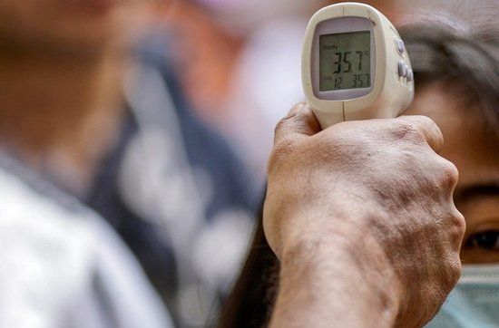
All arrivals especially from affected countries are screened to identify guests with symptoms of COVID-19 and are requested to measure their body temperature upon check-in.

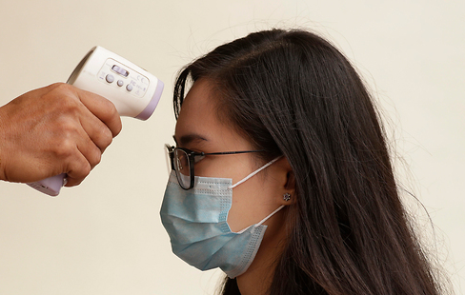
Past travel records within the last 14 days are obtained from each check-in guest for record. Manager on duty refer all sick guests or suspicious cases to proceed to the hospital for medical check following the Amwaj Oyoun Resort & Casino guidelines of suspected cases.

Front Office should have available the telephone numbers of the health authorities, medical centers, public and private hospitals, and assistance centers for use whenever there is the possibility that a guest may be ill.

Rooms are not to be accommodated until 48 hours following the guests’ departure have passed, during which all sterilization and disinfection procedures are carried out in accordance with the approved health standards.

The Front Office is equipped with a medical kit (masks, disinfectant, gloves, protective apron). Front Office staff follow the Staff COVID-19 Protocol page 4 and 5.
The hotel’s main entrance, the lobby and desk are sprayed with qualified disinfectant every hour.
Group check-in with more than 2 guests at a time is not allowed. Group check-in only with support of tour leader or manager on duty. Guest should respect floor markings if existing.
Always we remind our guest to maintain social distancing whilst in the hotel lobby.
The sitting areas in the lobby will be at least 1.5 to 2 meters from each other. Hotels avoid grouping of guests in the lobby.

Tour operators will conduct their meeting in meeting rooms if applicable or see their guests by couple only.

Guest will be advised that the maximum load of the elevator is 50% of the capacity to maintain social distancing with other guests. The Front Office employees should remind this to the guest upon check-in.

Front desk employees should encourage guests to use their electronic cards and credit cards for payment.

Assigning one building or floor inside each hotel to be utilized as quarantine for mild symptoms cases, non-critical illness cases and suspected illness cases.

To deliver a letter of following instruction to our guest:

Guest Stay Instructions Letter (to be Amended by Each Hotel):
- Wash your hands regularly with soap and water. It takes about 20 seconds to wash hands properly.

- Use a tissue for coughs and sneezes. Dispose them in the room waste bin.

- If you don’t have a tissue use your sleeve.

- Avoid touching your eyes, nose and mouth with unwashed hands.

- If you feel unwell, feverish or develop a cough, stay in your room. We will give you necessary advice. Do not go to the restaurant if unwell, food will be brought to your room.

 | Leading from the Lobby
Arrival | During Guest’s stay | Departure
Front Office team to ensure that guests stay in 2 m distance from each other. | FO to ensure that guests stay in 2 m distance from each other. | FO to ensure that guests stay in 2 m distance from each other.
Temporary signs for check-in only if 2  employees are working at the same time at the Front Office. |  | Temporary signs for check-in only if 2  employees are working at the same time at the Front Office.
All arrival guests must follow the two-way traffic towards the reception whilst maintaining the social distancing between them. | Managers on duty to proactively assist guest in a quick and efficient way in order to diffuse long queues. | All departure guests to use the departure section at the reception unless the check-in counter is also available.
Recommendation: A sign to be in place to guide guests toward the check-in section of the Front Office. | Tour operator, should use meeting rooms to conduct their meeting for group arrival instead of lobby. | A sign must be in place to guide guests toward the check-out counter section of the Front Office.
Manager on duty should also be present during the peak hours of operation in the lobby and help to divert guests to the desk or offer immediate assistance. | Manger on duty to politely encourage guests to use another sitting area rather than one close to reception. | Guest can be encouraged to settle their bill the  night before they departure.
For group arrival the tour operator should handle the check-in inviting one couple at the time whilst the others keep their social distance. |  | Particular attention needs to be made at the luggage room allowing one person at the time
The single queue works well when the direction and structure of the queue is defined by physical features like queue barriers.

Official leaflets on basic hygiene practice and COVID-19, in different languages “are an additional option” and will be distributed to our guests.

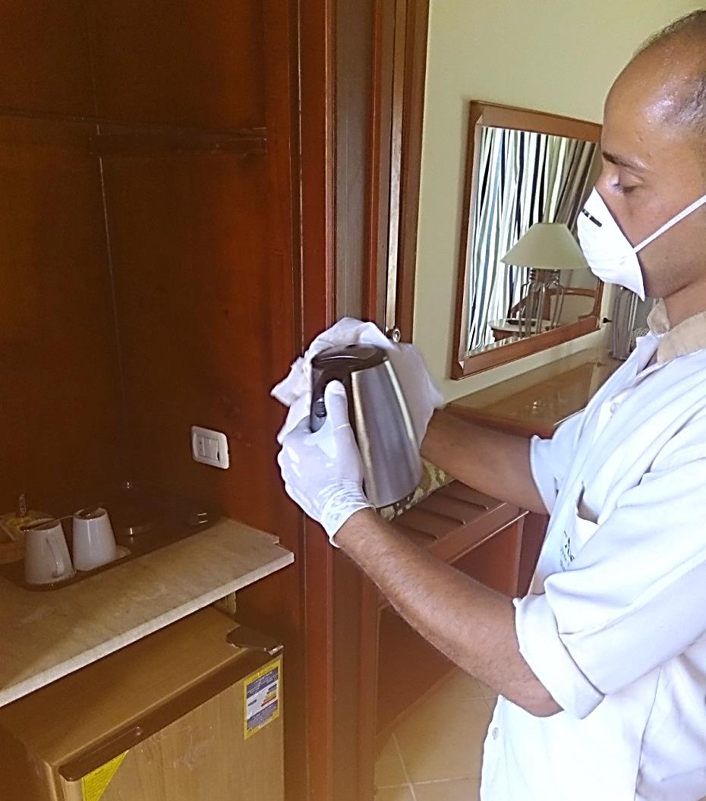
Having a sanitary hotel room is important under normal circumstances but with Coronavirus cases mounting in the world, it's a crucial way of helping protect our guests from picking up the COVID-19.
Housekeeping and cleaning staff should inform the management or the reception desk of any possibly sick guests in their rooms.
Provide a steam machine to disinfect furniture and fabrics.
Not to change bedding on a daily basis, and to rely more on self-service in cleaning rooms.
Safe disposal of waste (in coordination with the Ministry of
Health and Population).
Housekeeping team is regularly trained on Amwaj Oyoun resort & Casino POSI procedure and how to handle infected or suspected rooms.

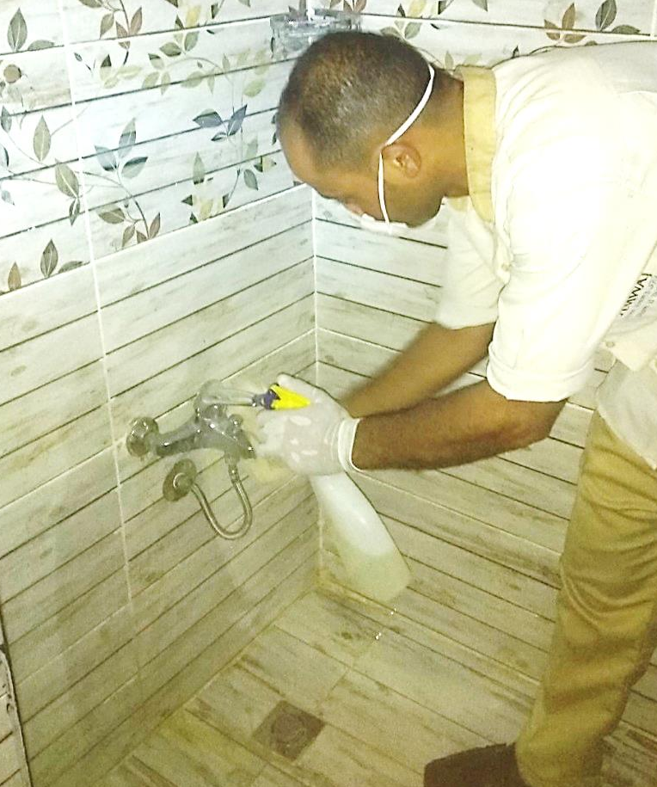
A cleaning plan is followed for guest rooms by focusing on high touch areas which are used by everyone in the room as well as housekeeping and else visiting the room. So we give them a good wipe down on daily basis.
- Chlorine at 1000 ppm is used for disinfection procedure.
- We use specific clothes, scourers (sponges) and bags.
- We increase the frequency of cleaning and disinfecting process.
- We supply housekeeping team by sufficient disinfectants,
PPE and other supplies.
- No papers or magazines to be placed inside the rooms.

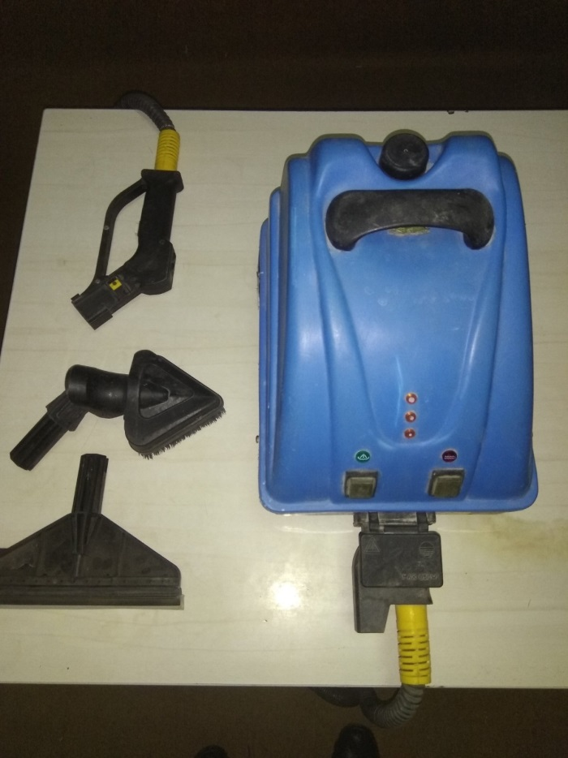

For soft furnishings (sofas, mattresses etc.), other cleaning
procedures may be used e.g. steam cleaning (vaporizer).

Linen Management
- Linens and clothes should be put in special, marked laundry
bags and handled carefully.
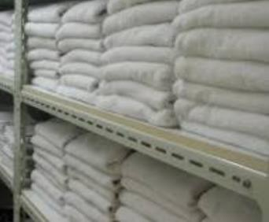
- Clean and disinfect hampers or other carts for transporting of laundry.
- Instructions is given for washing them in hot cycles (70ºC or
more) with the usual detergents.

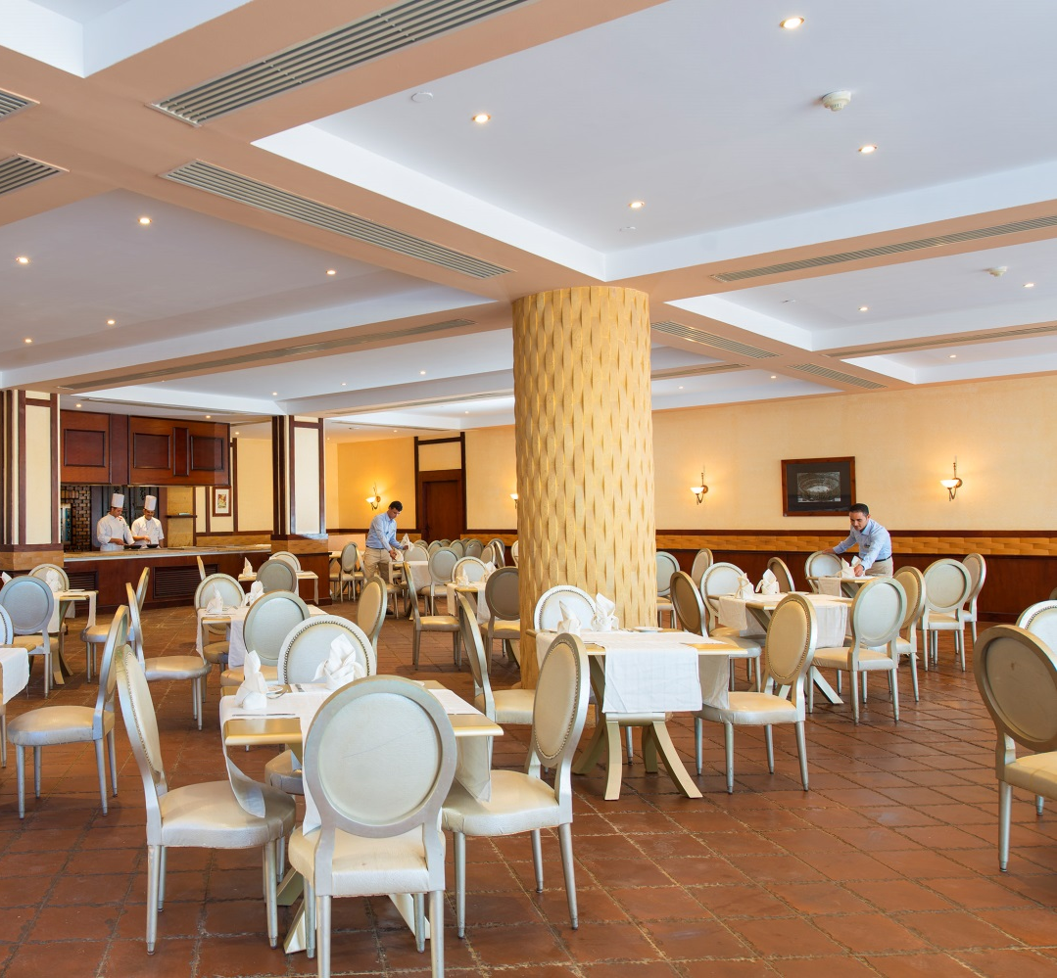
Different measures from food preparation to dining experience have been implemented to ensure food hygiene safety.

Set menus and a la carte menus to replace the standard open
buffets.

We maintain the highest levels of cleaning across our buffets.

Inside the a la carte restaurants ready-made appetizers and starters set-ups are served to the table once guests are placed.

No sweets, cookies, fruit or candy bars in the public areas. Shisha to be banned.
Coffee machines, soda machines, and others, in particular parts which are more in contact with the hands of users, are cleaned and disinfected after each service and more often if necessary.

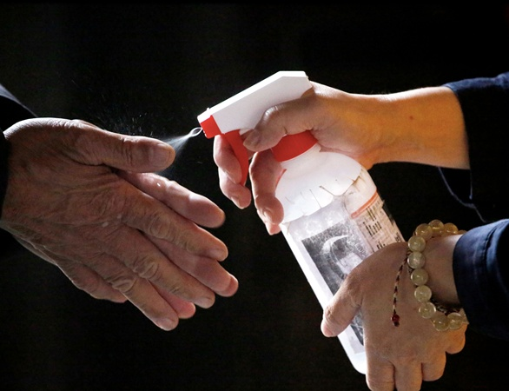
All dishes, silverware and glassware should be washed and disinfected in a dishwashing machine, including items that have not been used, as they might have been in contact with the hands of guests or employees.

All tableware including salt & pepper shakers, toothpick holders, sugar containers, tent card holders, menus and bill folders are cleaned and sanitized on a daily basis.

All crockery and utensils used at the buffet counters, including tongs, spoons and under liners are changed and sanitized every 20 minutes.

Dining tables and chairs are sanitized with designated disinfectant before serving new guests, so our guests can find a pleasant and safe dining experience at all restaurants.

Leave a minimum distance of 2 m between dining tables, and

1 m between each person on the table taking into consideration families with a maximum of 6 chairs on the large table.

Maximum four people are allowed per table.

The indoor and outdoor seating capacity of the outlets and restaurant will not be more than 40 % of the total restaurant capacity based on the provided regular capacity.

It is recommended to open all restaurants at the same time to utilize the entire restaurants facilities and implement several sittings.

The restaurant will provide a one direction way and walking flow with 2 m distances for enabling social distancing.

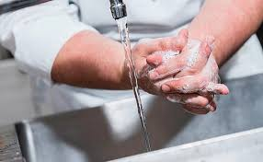
Disinfectant dispenser at the entrance of all restaurants & outlets will be available. Disinfectants wipes to be placed on the tables.

Service staff ensure and ask guests to use sanitizer gel at the
restaurant entrance.

Face masks and gloves are provided and available for guests upon request.

Awareness signs to be available around the restaurant.

All staff perform personal hygiene strictly, focusing on frequent regular handwashing, cough hygiene etc.

Spa Facility
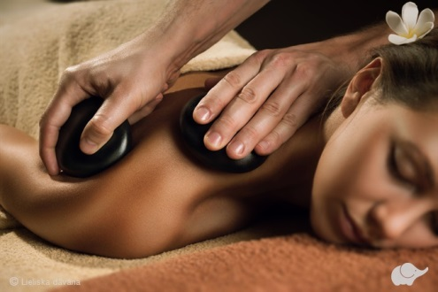
Spa facility is banned for the moment.

Gym Area
Hourly cleaning and disinfecting the entire room and high touch points, keeping equipment apart and preventing showering in the gym. It is a must to clean the equipment after the use of every guest.
Not accepting visitors from outside the hotel.

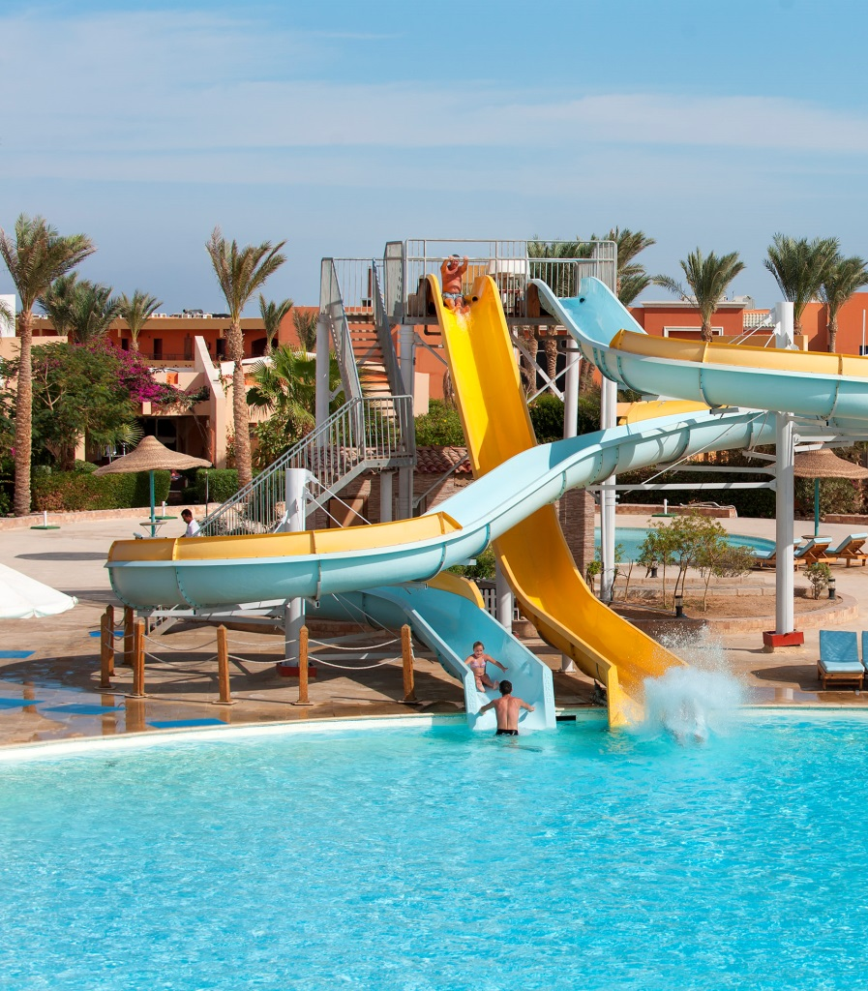
All Hotel Public Areas
We increased cleaning and hygiene protocols.
We offer disinfectant dispensers in public areas to our guests.

General good practices, sufficient dressing rooms, shower rooms, toilet facilities and lockers for the guests are available.

Adequate handwashing facilities including liquid soap, paper towels, hand dryer and hand gel are available.

Regular disinfection of high-touch areas such as door handles, toilets and elevator buttons with disinfectant.

Entertainment Team
Every entertainer needs to take his/her temperature in the
morning before going to work.
If the entertainer has an increased temperature contact directly the doctor.
The hotel provide stationary disinfection dispensers at the
kids club and gym.
Every entertainer and every guest has to sanitize their hands when joining the activities.

Entertainment Team
Every entertainer must wash hands in between every 60 - 90 minutes.
The entertainment team is responsible for cleaning and sanitizing all sport materials before using.
Fitness classes: Every guest is responsible for cleaning and sanitizing their fitness material after use.
Entertainers should avoid group activities for guests. Avoid body contact activities and discos in the evening. During daily sports ensure guests are maintaining at least a distance of 1.5 m from each other.
The entertainers have to point out that during the whole program the guests have to keep a minimum distance of 1.5 m to each other.

Entertainment Team
All sport activities with direct body contact should be prohibited.
The entertainment team should inform the guests in the presentation and during the day about the hygiene regulations.
No parties or weddings will be allowed inside the hotel.
The disco will be temporarily closed.
All additional information shall be pointed out at the entertainment information board.

Pools Areas
The lounge chairs around the swimming pool should be in group of 2 and at least 2 meters away
from each other.

Kids Club
Monitoring signs of respiratory problems for any kid.
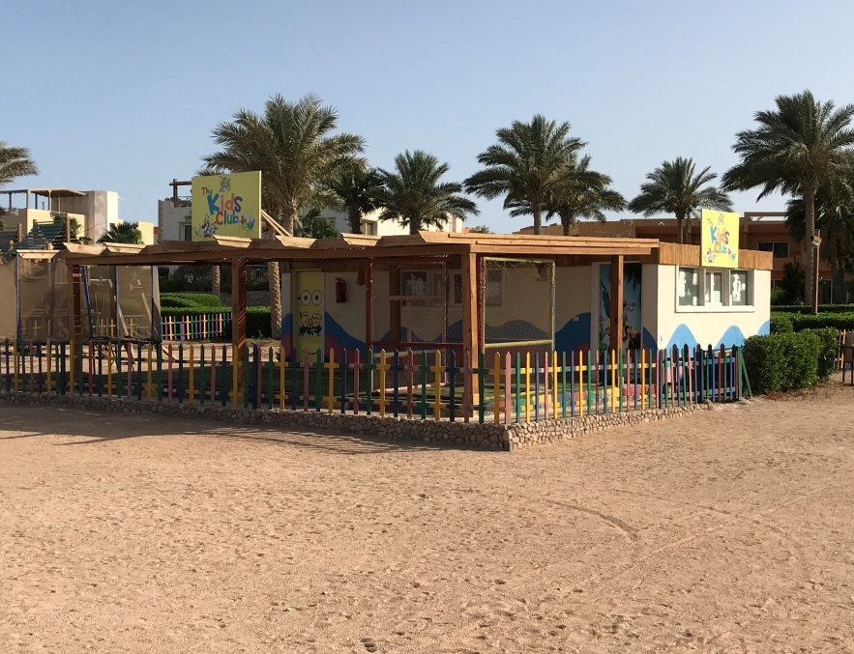
Special cleaning and disinfection protocols should be applied minimum twice a day.
Every kid and all parents have to sanitize their hands when joining/entering the kids club.
No open food is allowed in the kids club (no fruits, no birthday cake, no candies).
Every program with body contact is prohibited during the pandemic situation. Thus activities like face painting or similar are not allowed.
Small groups are helpful to reduce the possibility of infections. Therefore,
the maximum number of kids per group is 8.
The hotel needs to provide a sufficient number of colored pens/pencil for every single child.
Sharing the pencils is not allowed. The entertainer need to take care
about. The entertainer must sanitize all pencils after use.

It is considered a high degree of interaction among guests and workers. This requires specific attention and can be only carried out with the permission of the local authorities.
Every staff member follows Staff COVID-19 Protocol.
One direction way system needs to be in place.
Face/eye mask and disposable gloves must be available for each participant. Strict cleaning and disinfection plan, especially for high-touch objects.
Housekeeping team to follow previously mentioned procedure. Food and beverage team to follow previously mention procedure.
Set-up, table arrangements, coffee breaks etc. will be in place according to WHO instructions.

Water Disinfection
- We maintain the concentration of disinfectant in water for consumption and in pools or spas within the limits according to international norms and standards.
- We verify that water flow has occurred and review.
- Legionella protocol is applied.
- Water samples will be taken from different areas before reopening to make sure that water is free from any hazards.

Air-Conditioning
- Although COVID-19 is not transmitted by air but from person to person through small droplets from the nose or mouth when an infected person coughs or exhales, attention should be given, as in normal circumstances, to monitoring the condition of filters and maintaining the proper replacement rate of indoor air.
- The proper functioning of ventilation, air exchange, and dehumidification equipment of covered
pools are in place.

Building Systems
Electrical systems, plumbing system, lighting system etc. in proper maintained condition when
reopening.
Hotel Equipment
Dishwashing machines, laundry equipment, ice makers, fridges and freezers, kitchen hoods etc. in proper maintained condition.
Beach, Swimming Pools/Fountains/Water Features
Cleaning and disinfection plans are in place including chemical shock, filtration, backwash, monitor turbidity and lab. samples. To use the maximum chlorine concentration (5 mg/l) and bromine (10 mg/l) to nullify COVID-19.
Regular cleaning for the beach and pool areas, including tables, deck chairs, sunbeds, floor etc.
after the use of each guest as well as after the operation hours.
Leave at least two meters distance between each sun lounger. Handing beach towels in rooms to minimize contact.
Reducing recreational activities on the beaches and on swimming pools.

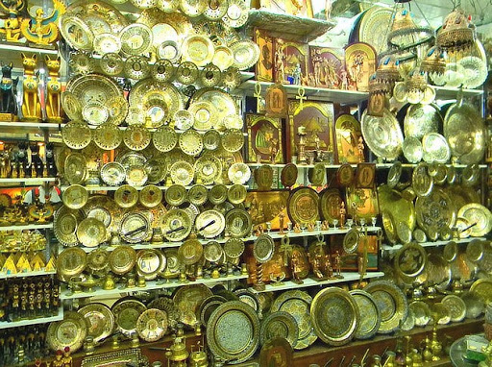
They take full instructions to follow the hotel protocol including strict cleaning and disinfection plan and Staff COVID-19 Protocol.

To have enough personal hygiene facilities as hand soaps
and hand sanitizers.

To maintain social distance and remind guest of hand sanitizer before leaving.

Suppliers of goods and services as well as contractors follow safe systems of work to prevent the
spread of COVID-19.
Good communication with suppliers to secure for hotels the below supplies.
  - A secure stock of face masks for both guests and employees be kept in the hotel store.
  - Hotel must secure at least 10 % more face masks based on the maximum capacity of guests and
employees for emergency purpose.
  - Hotel should have enough thermometers in stock to control guests and employees.
  - Hotel should have enough disinfectant and cleaning chemicals.
  - Hotel should have enough PPE.

During goods delivery inside the hotel receiving area, special precautions will be put in place. Truck drivers must wear masks and gloves whilst making a delivery. Hotels should strictly apply temperature measurement policy.
Store staff follow COVID-19 Protocol.
Hygiene procedures for delivery and storage process are kept in place.
Suppliers who have visited COVID-19 affected countries should follow travel restrictions in place.
Suppliers who are under an active quarantine order are not performing work at the hotel.

To allow hotels to execute flawlessly, it is recommend that the hygiene team support the hotel’s
overall operation and help management to apply the guidelines smoothly.
The hygiene team MUST be knowledgeable about COVID-19 and its prevention. Some of the keys duties include:
- Supporting the front office manager with the logbook and ensuring that illness cases are followed
through accordingly.
- Check equipment of medical kit.
- Spot check different areas in the hotel on a daily basis. These include: Canteen, employees cloakroom, employee smoking area etc., ensuring there is no big gathering of employees at that time.
- Check if the Human Resources Department check employee’s temperature in case needed.
- To fully support Housekeeping in case of a suspected illness.
- Supports in training/coaching.

  - Be the main contact person for the local hospitals/authorities/medical officer.
  - Check the entrance of the restaurant with regard to the number of guests and distance of tables.
  - Check restaurant and social distancing of guests in the restaurant and bars etc.
  - Check all the distance between sunbeds and ensure that disinfection stations are always fully equipped including paper towels etc.
  - Submit a regular report of any particular observation.
  - Direct reporting to General Manager and performing any additional task that may be required to support the hotel.
  - Train and continuously getting up-dates from authorities and sharing this information.

General Manager’s Role

- Building his/her crisis team which includes the head of departments.
- Defines roles, responsibilities of each department and how they can contribute to the effectiveness of the program.
- Takes appropriate corrective and preventive actions and continually improves the effectiveness of the program.
- Ensures that employees are familiar and comply with the requirements of the program.
- Commits to develop, implement and continually improve the effectiveness of the program.
- The measures and requirements of the program should be available.

A crisis team involving members of each relevant department (HODs) can support management in the implementation of the action plan and timely identification of required adjustments. This will enable the hotel to operate smoothly and still meet guest’s expectation while maintaining a high level of hygiene in the hotel.

  - Responsible of all disinfection and cleaning plan.
  - Ensure the sickness, illness procedure kept in place.
  - Ensure the action plans are done in case of nonconformance points.
  - Responsible of applying and updating the guidance strictly.

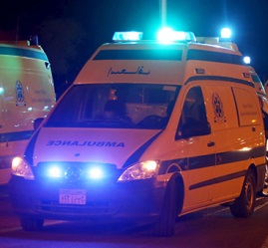
Affected Guest in the Hotel
A continued stay of the sick person in the establishment is not recommended.

The person can be isolated in a room on a temporary basis until the intervention of a hotel doctor or local health authorities, and provided the room is not shared with other guests.

No visitors should be permitted to enter the room occupied by the affected guest.

In Case of an Infected Person in the Hotel

The experience of the hotel doctor should be called in case of an infected guest or employee in the hotel.

Depending on the availability of rooms, accompanying persons, if any, should be moved to a
different room.

Should the room next to the affected guest be occupied, it is paramount to move this unaffected guest to a different room. This must be done with careful discretion.

It is highly recommended that one designated person looks after the guest who has been affected. DO NOT use different employees.

In Case of an Infected Person in the Hotel

Non-Affected Guests
These are persons considered to have had a low-risk exposure. They should be provided with information about the disease, its transmission, and preventive measures.

They should be asked to self-monitor for COVID-19 symptoms, including fever, cough or difficulty in breathing for 14 days from the date of departure of the confirmed case from the establishment.

Should they develop symptoms indicative of COVID-19 within 14 days, they should be asked to
immediately self-isolate and contact local health services.

Employees
Employees involved in the suspected case should apply infection prevention and control practices according to WHO guidance. They should routinely perform hand hygiene and wear a medical mask, eye protection, gloves and gown when loading suspected COVID-19 patients for transport in the ambulance. They should ensure that they clean their hands before putting on PPE and after removing it. Ambulance or hotel transport vehicles should be cleaned and disinfected with special attention to the areas in contact with the suspected case.
Direct contact employees by affected guest should be isolated in individual rooms and be monitored by the hotel doctor.

Hotel Management
Hotel Management to contact immediately local health authorities.
Inform crisis team to do their actions and precautions applying POSI procedure.

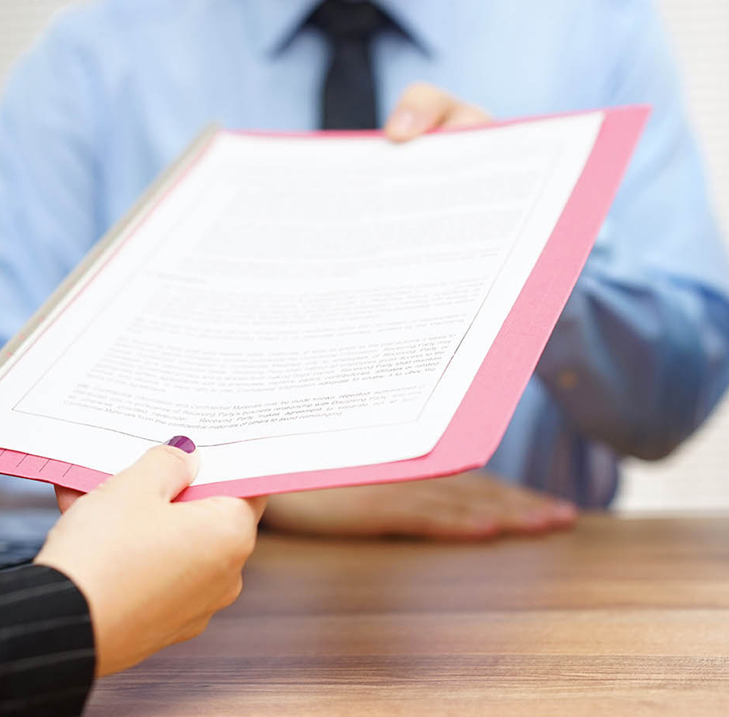

Creating and updating the COVID-19 related documents, consider plans and procedures that should be in place.

Ensure that documents and records are retained for at least 6 months for traceability.

Ensure compliance to government orders, guidelines
and health advisories on the COVID-19.

    - Face masks, gloves, thermometers, hand gel, disinfectants for all departments.
    - Face masks, gloves, hair nets, eye protections, long sleeve gowns, disposable aprons for Housekeeping and any person getting in contact with an infected person.
    - Steam machine for soft furniture.
    - Colored pens for each single kid during his stay.
    - Floor markings for any place where social distance is required, e.g. Front Office desk.
    - Movable balustrades to direct guests in case of big arrivals and departures.

Amwaj Oyoun Resort & Casino hotel are required to apply this protocol which is based on WHO, CDC and the Egyptian Ministry of Health’s (MOH) instructions.
Additional plans or information can be added according to hotel.

